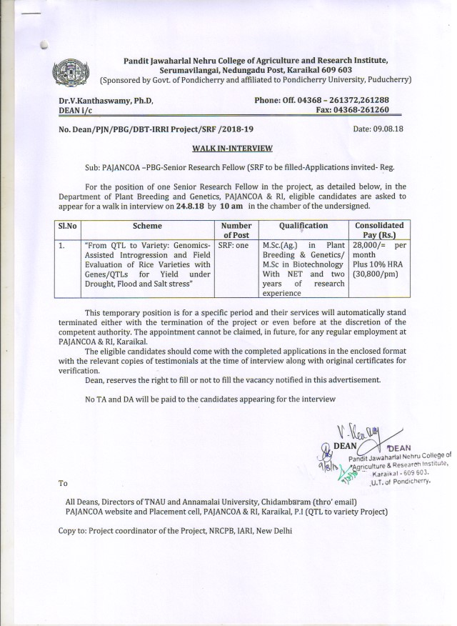


Pandit Jawaharlal Nehru College of Agriculture and Research Institute,
Serumavilangai, Nedungadu Post, Karaikal 609 603
(Sponsored by Govt. of Pondicherry and affiliated to Pondicherry University, Puducherry)

APPLICATION FOR THE POST OF…………………………………………
1 | Name | :
2 | Sex | :
3 | Age & Date of Birth | :
4 | Place of Birth | :
5 | Father’s / Guardian’s Name | :
6 | Nationality | :
7 | Permanent Address | :
8 | Address for correspondence | :
9 | Educational Qualifications | :

Degree | Institute/University | Specialisation | OGPA/MARKS

Position | Employer | Period |  | Nature of work
Position | Employer | From | To | Nature of work

10 | Experience | :

11 | Publications (Popular/Research) Enclose list | :
12 | Awards / Medals | :

DECLARATION
I hereby declare that the particulars given above are correct and I am aware that action may be taken against me as per the Rules of the College, if any of the information given above is found to be incorrect. If selected, I undertake to abide by the Rules and Regulations of PAJANCOA & RI, Karaikal.

Place:
Date: Signature of the candidate

